Experiment No: 06
Name of the Experiment:
- Write an assembly language program to display 'o' if AL contains 1 or 3 and display 'e' if AL contains 2 or 4 using EMU8086.
- Write an assembly language program where a character is read and if it is an uppercase letter display it, otherwise terminate the program using EMU8086.
Theory: EMU8086 assembly handles conditional logic using compare and jump instructions alongside DOS interrupts. The CMP instruction subtracts two values without storing the result, setting flags that conditional jumps like JE, JB, and JA use to alter program flow. To check if AL holds an odd digit, compare it against '1' and '3', then jump to a label that loads 'o' into DL for display. To check for an even digit, compare AL against '2' and '4', then jump to a label that loads 'e' into DL for display. For uppercase letter validation, compare the input character against 'A' using JB to exit if below, and against 'Z' using JA to exit if above. If the character passes both checks, move it to DL, set AH to 2, and call INT 21H to print it. Unconditional jumps like JMP transfer control to a specific label regardless of flag conditions. Finally, load 4CH into AH and call INT 21H to terminate the program and return control to DOS.

Code & Output:
i) Code to display 'o' if AL contains 1 or 3 and display 'e' if AL contains 2 or 4:
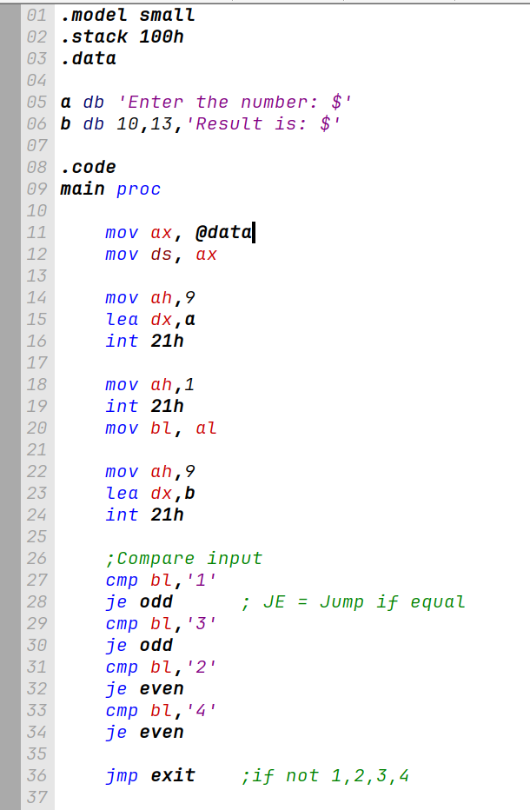
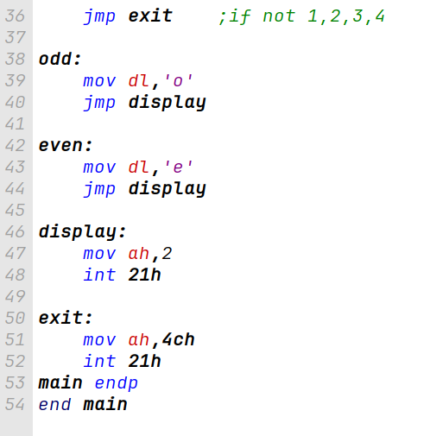

Machine Code:
B8 20 07 8E D8 B4 09 BA 00 00 CD 21 B4 01 CD 21 8A D8 B4 09 BA 13 00 CD 21 80 FB 31 74 11 B2 6F EB 04 B4 02 CD 21 B4 4C CD 21

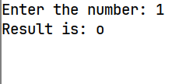
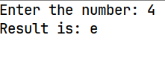
Output:

ii) Code to display a user-input uppercase letter:

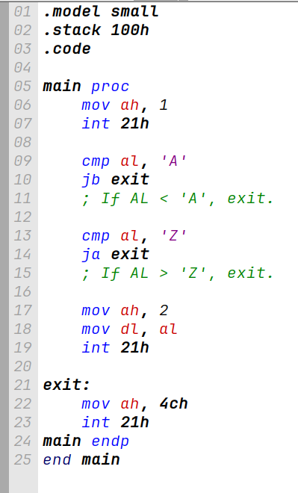

B4 01 CD 21 3C 41 72 0A 3C 5A 77 06 B4 02 8A D0 CD 21 B4 4C CD 21
Machine Code:


Output:

Conclusion:
The program was executed successfully in the EMU8086 environment, and no errors were found. We successfully learned how to implement conditional logic using CMP and conditional jump instructions like je (jump if equal), jb (jump if below) and ja (jump if above).

